**Amarilda Celhaka**

**Project #3**

**CMP SCI 3130**

**Binary Search Trees**

* Creating a binary tree using the elements of the given array

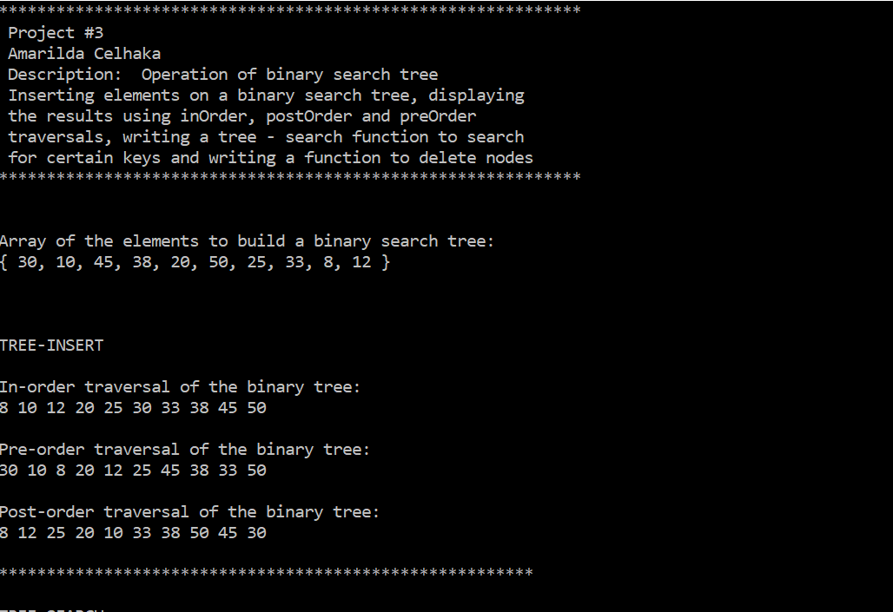

* Searching for the keys 38 and 9

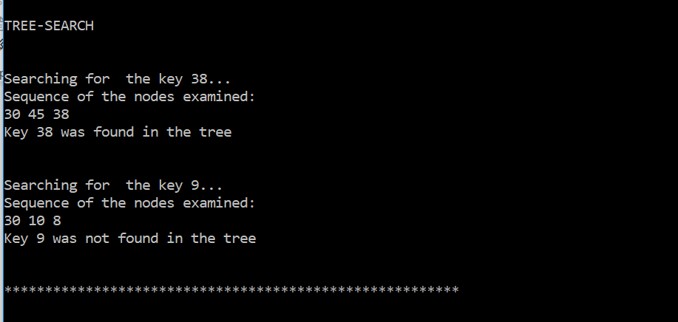

* Deleting the node with key 10 and displays the results of *inorder, postorder* and *preorder*

